**Sir Syed CASE Institute of Technology**



PROGRAMMING FUNDAMENTALS

Submitted by: **Maira Emaan Nasir**

Roll No: 2430-0153

Department: **BSCS**

Submitted to: **Sir Jawad**

Date: 7/11/24

ASSIGNMENT: 02

Task: 01

Code:

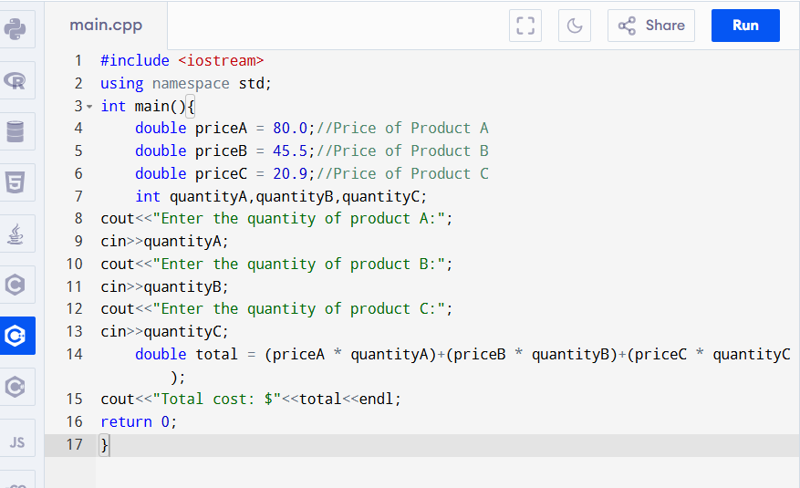

Output:

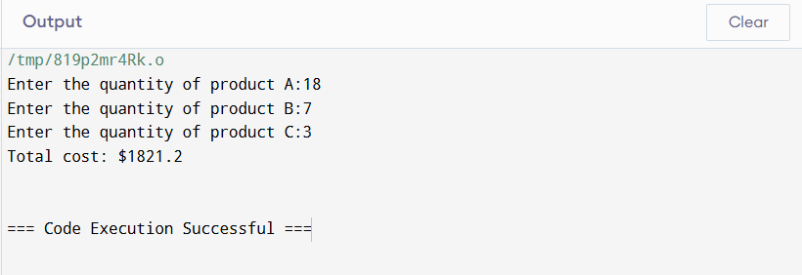

Task: 02

Code:

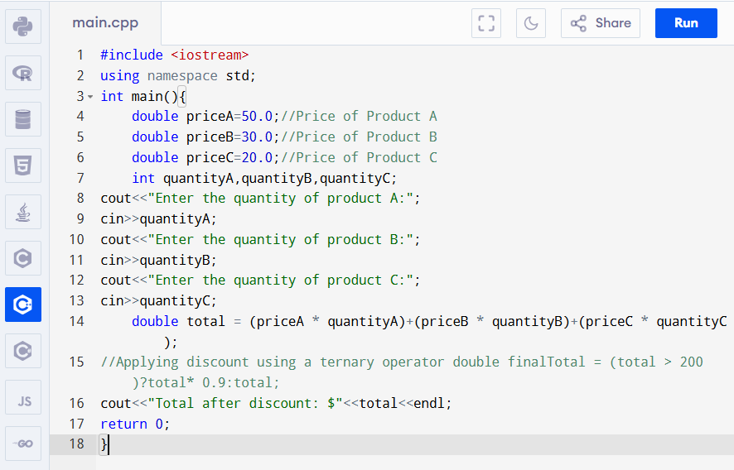

Output:

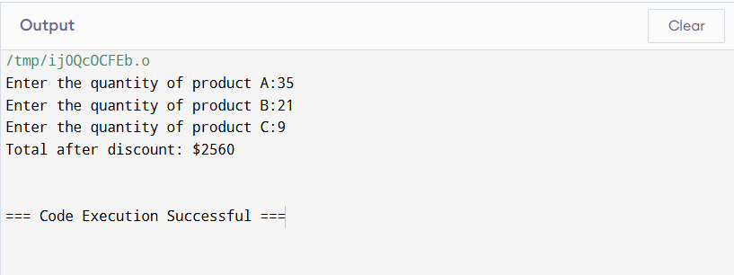

Task: 03

Code:

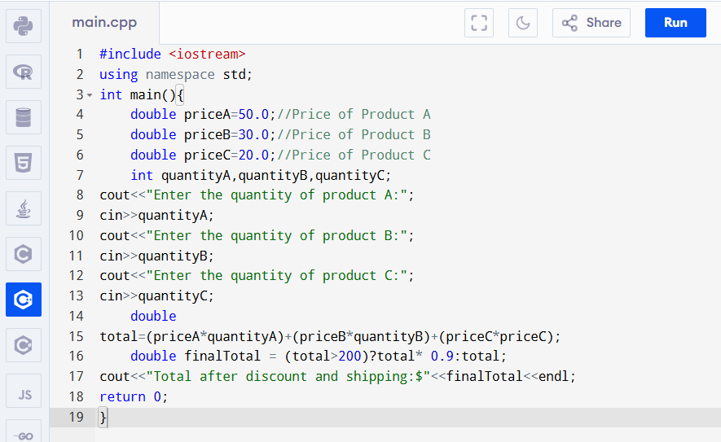

Output:

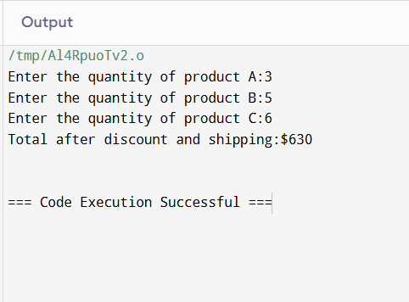

Task: 04

Code:

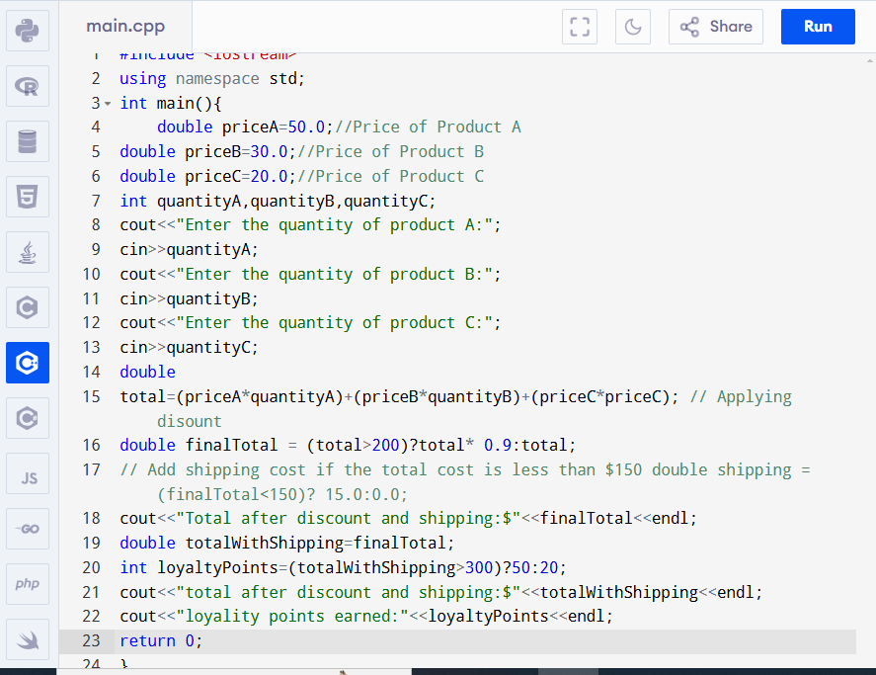

Output:

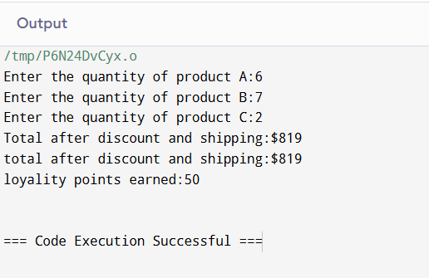

Task: 05

Code:

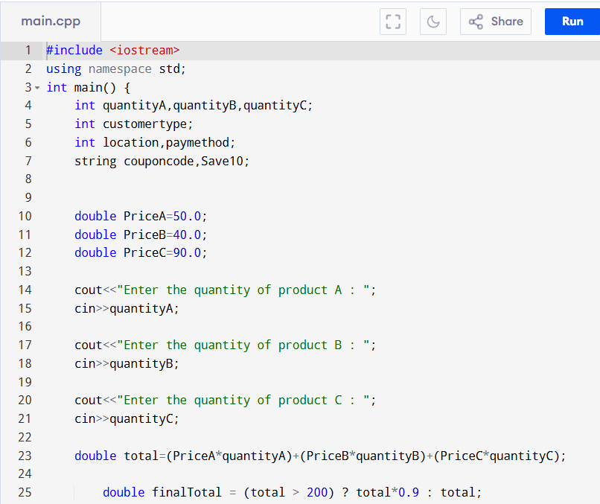

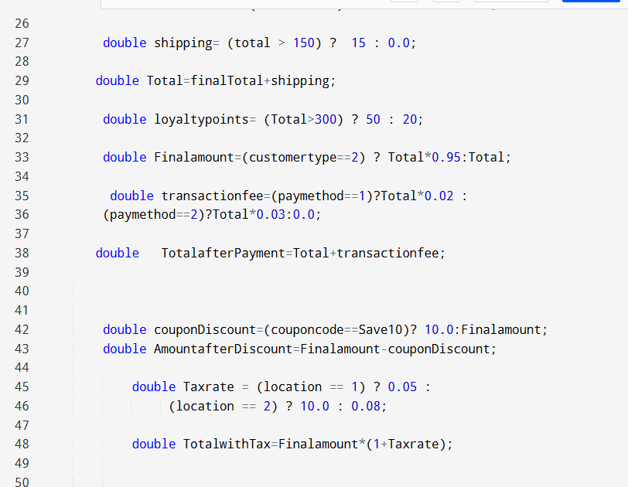

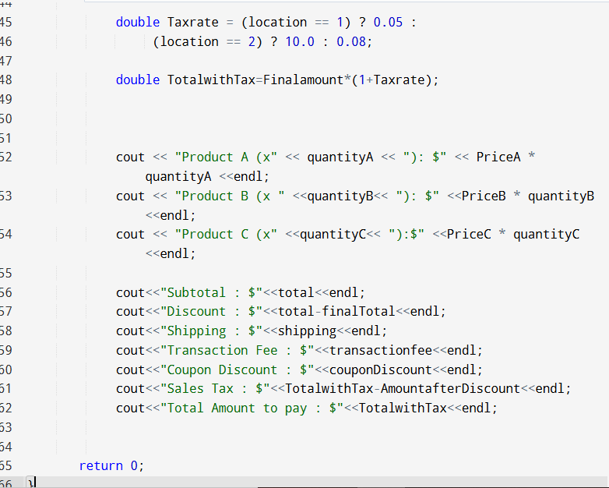

ADDITIONAL TASKS:

SHIPPING:

CODE:

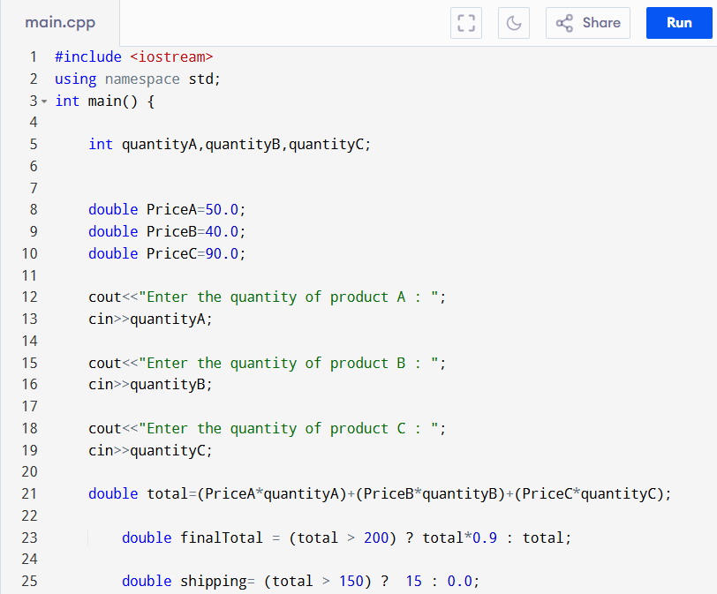

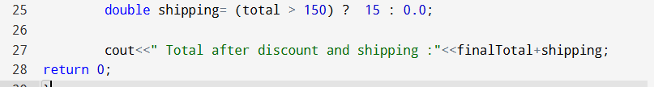

OUTPUT:

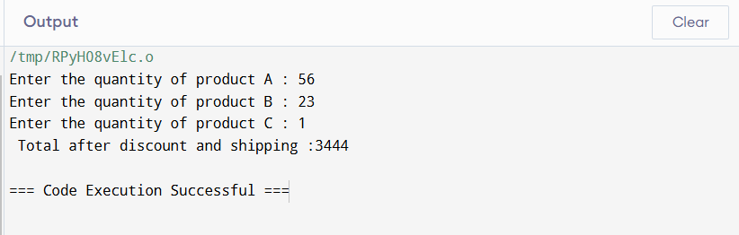

PRODUCTS TOTAL:

CODE:

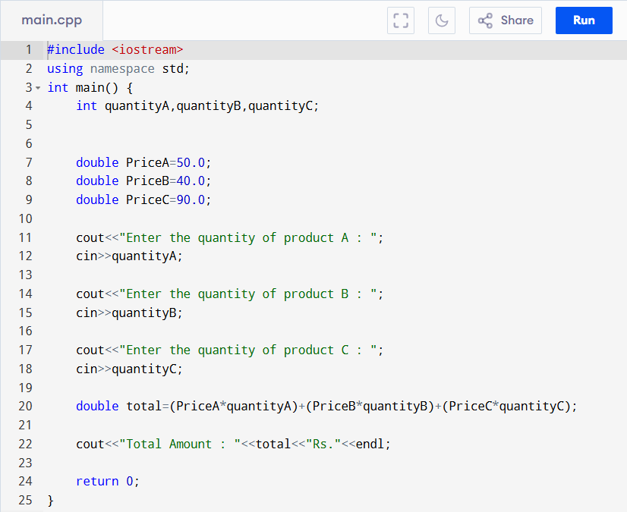

OUTPUT:

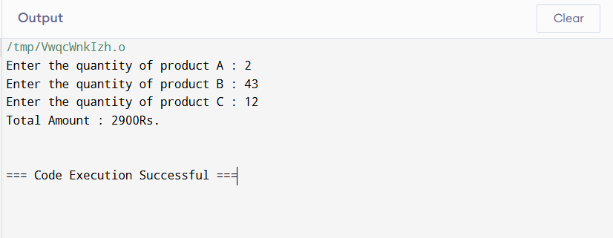

LOYALITY POINTS:

CODE:

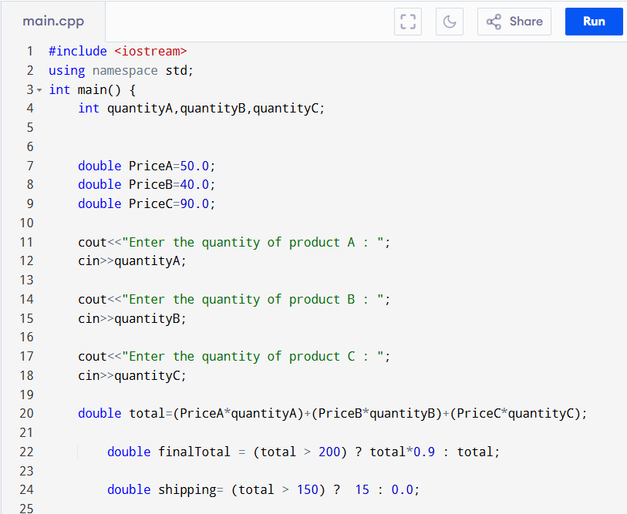

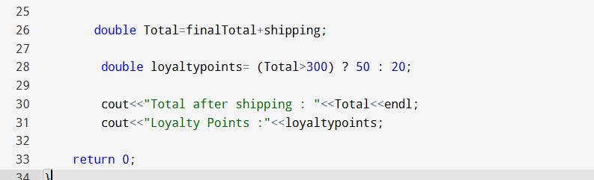

OUTPUT:

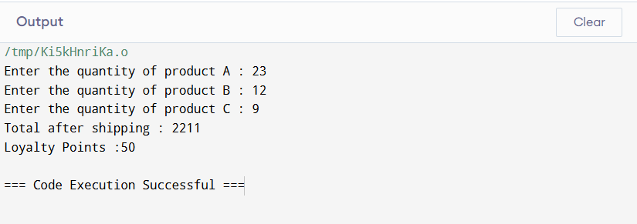

COUPON DISCOUNT:

CODE;

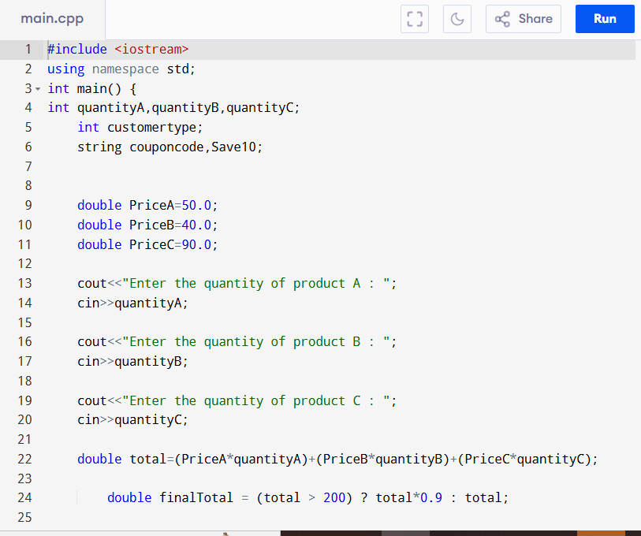

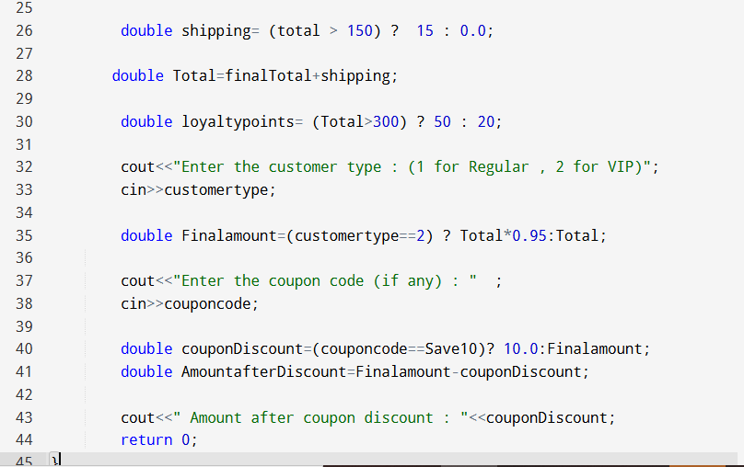

OUTPUT:

